List of countries and capital cities around the world in English

Countries and capital cities from around the world

A list of some countries and cities from around the world.
The list shows the country first with the capital city last. United Kingdom - London

List of countries and capital cities in English
Afghanistan - Kabul  Albania - Tirane  Algeria - Algiers  Andorra - Andorra la Vella  Angola - Luanda  Antigua and Barbuda - Saint John's  Argentina - Buenos Aires  Armenia - Yerevan  Australia - Canberra  Austria - Vienna  Azerbaijan - Baku  Bahrain - Manama  Bangladesh - Dhaka  Barbados - Bridgetown  Belarus - Minsk  Belgium - Brussels  Belize - Belmopan  Benin - Porto-Novo  Bhutan - Thimphu  Bolivia - La Paz  Bosnia and Herzegovina - Sarajevo  Botswana - Gaborone  Brazil - Brasilia  Brunei - Bandar Seri Begawan  Bulgaria - Sofia  Burkina Faso - Ouagadougou  Burma - Rangoon  Burundi - Bujumbura  Cambodia - Phnom Penh  Cameroon - Yaounde  Canada - Ottawa  Cape Verde - Praia  Central African Republic - Bangui  Chad - N'Djamena  Chile - Santiago  China - Beijing  Colombia - Bogota  Comoros - Moroni  Costa Rica - San Jose  Cote d'Ivoire - Yamoussoukro  Croatia - Zagreb  Cuba - Havana  Cyprus - Nicosia  Czech Republic - Prague  Democratic Republic of the Congo - Kinshasa  Denmark - Copenhagen  Djibouti - Djibouti  Dominica - Roseau  Dominican Republic - Santo Domingo  East Timor - Dili  Ecuador - Quito  Egypt - Cairo  El Salvador - San Salvador  Equatorial Guinea - Malabo  Eritrea - Asmara  Estonia - Tallinn  Ethiopia - Addis Ababa  Federated States of Micronesia - Palikir  Fiji - Suva  Finland - Helsinki  France - Paris  Gabon - Libreville  Georgia - Tbilisi  Germany - Berlin  Ghana - Accra  Greece - Athens  Grenada - Saint George's  Guatemala - Guatemala City  Guinea - Conakry  Guinea-Bissau - Bissau  Guyana - Georgetown  Haiti - Port-au-Prince  Honduras - Tegucigalpa  Hungary - Budapest  Iceland - Reykjavik  India - New Delhi  Indonesia - Jakarta  Iran - Tehran  Iraq - Baghdad  Ireland - Dublin  Israel - Jerusalem  Italy - Rome  Jamaica - Kingston  Japan - Tokyo  Jordan - Amman  Kazakhstan - Astana  Kenya - Nairobi  Kiribati - Tarawa  Kuwait - Kuwait City  Kyrgyzstan - Bishtek  Laos - Vientiane  Latvia - Riga  Lebanon - Beirut  Lesotho - Maseru  Liberia - Monrovia  Libya - Tripoli | Liechtenstein - Vaduz  Lithuania - Vilnius  Luxembourg - Luxembourg  Macedonia - Skopje  Madagascar - Antananarivo  Malawi - Lilongwe  Malaysia - Kuala Lumpur  Maldives - Male  Mali - Bamako  Malta - Valletta  Marshall Islands - Majuro  Mauritania - Nouakchott  Mauritius - Port Louis  Mexico - Mexico City  Moldova - Chisinau  Monaco - Monaco  Mongolia - Ulaanbaatar  Morocco - Rabat  Mozambique - Maputo  Namibia - Windhoek  Nauru - Yaren District  Nepal - Kathmandu  Netherlands - Amsterdam  New Zealand - Wellington  Nicaragua - Managua  Niger - Niamey  Nigeria - Abuja  North Korea - Pyongyang  Norway - Oslo  Oman - Muscat  Pakistan - Islamabad  Palau - Koror  Panama - Panama City  Papua New Guinea - Port Moresby  Paraguay - Asuncion  Peru - Lima  Philippines - Manila  Poland - Warsaw  Portugal - Lisbon  Qatar - Doha  Republic of the Congo - Brazzaville  Romania - Bucharest  Russia - Moscow  Rwanda - Kigali  Saint Kitts and Nevis - Basseterre  Saint Lucia - Castries  Saint Vincent and the Grenadines - Kingstown  Samoa - Apia  San Marino - San Marino  Sao Tome and Principe - Sao Tome  Saudi Arabia - Riyadh  Senegal - Dakar  Serbia and Montenegro - Belgrade  Seychelles - Victoria  Sierra Leone - Freetown  Singapore - Singapore  Slovakia - Bratislava  Slovenia - Ljubljana  Solomon Islands - Honiara  Somalia - Mogadishu  South Africa - Pretoria  South Korea - Seoul  Spain - Madrid  Sri Lanka - Colombo  Sudan - Khartoum  Suriname - Paramaribo  Swaziland - Mbabana  Sweden - Stockholm  Switzerland - Bern  Syria - Damascus  Taiwan - Taipei  Tajikistan - Dushanbe  Tanzania - Dar es Salaam  Thailand - Bangkok  The Bahamas - Nassau  The Gambia - Banjul  Togo - Lome  Tonga - Nuku'alofa  Trinidad and Tobago - Port-of-Spain  Tunisia - Tunis  Turkey - Ankara  Turkmenistan - Ashgabat  Tuvalu - Funafuti  Uganda - Kampala  Ukraine - Kiev  United Arab Emirates - Abu Dhabi  United Kingdom - London  United States - Washington D.C.  Uruguay - Montevideo  Uzbekistan - Tashkent  Vanuatu - Port-Vila  Vatican City - Vatican City  Venezuela - Caracas  Vietnam - Hanoi  Yemen - Sanaa  Zambia - Lusaka  Zimbabwe - Harare

List of countries with their capitals
Right click and choose save as
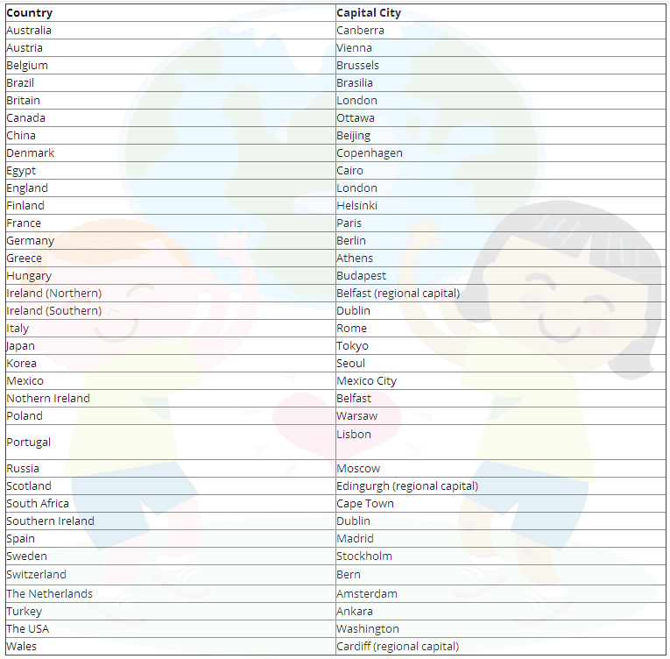

Lessons that might be related to countries and capital cities
Countries & nationalities list of nationalities in English
Where are you from? learning English
Places: Countryside Vocabulary List learning English vocabulary
Match the country to the capital exercise

Print the English lesson on learning countries and their capitals
To print the lesson, on learning on learning about countries and their capital. Right click on a white space and choose print. You can click on the printer icon just below and to the right of the contact us menu button at the top of the page or copy and paste the part of the exercise you want onto a word document and then print onto some paper.

Dictionary and how to use dictionaries
Click on the following link for the On line English dictionary - English lesson

Easy Pace Learning Forum
If you are struggling with a lesson or an exercise post a question we will try and help you or post your answers and let others compare

